**17MIS1139**

**S.SOWMIYA**

**LAB – 3**

**System Monitoring**

1. 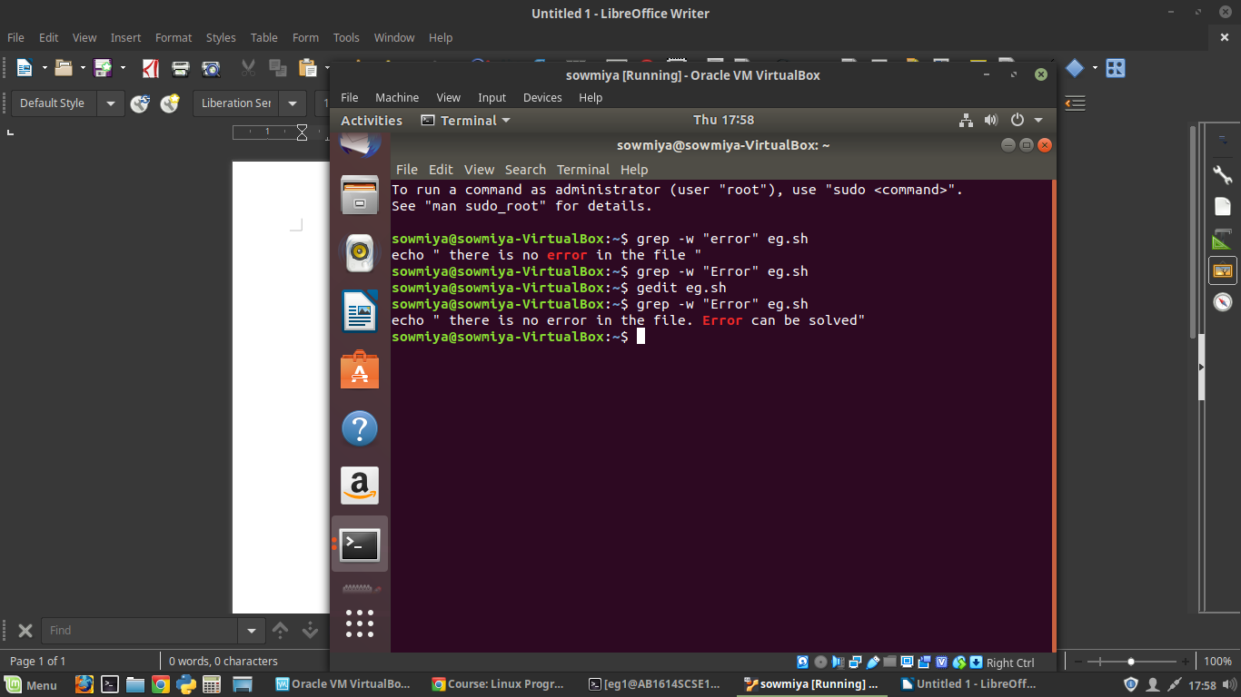**Write a shell script to search for a string in file**
2. **loop --> while + grep to search a string.**

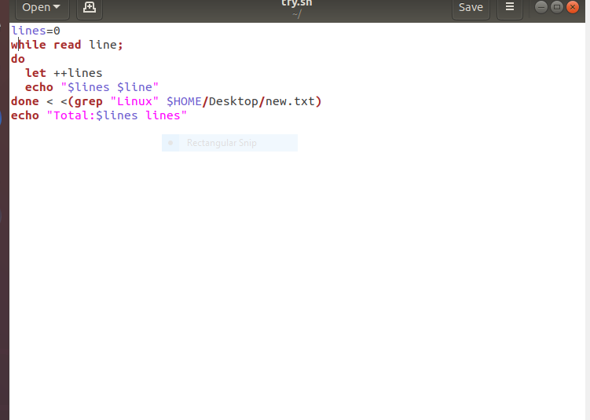

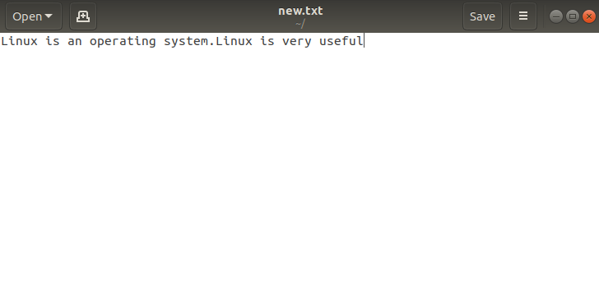



1. 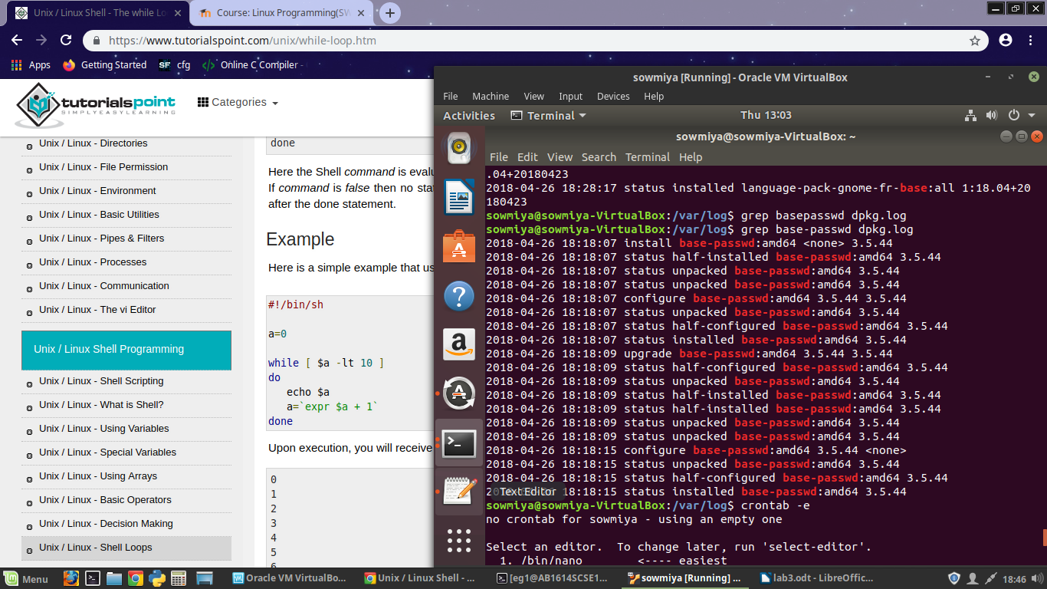**write a script that will check a file every hour to check for errror if error found display the error message.**

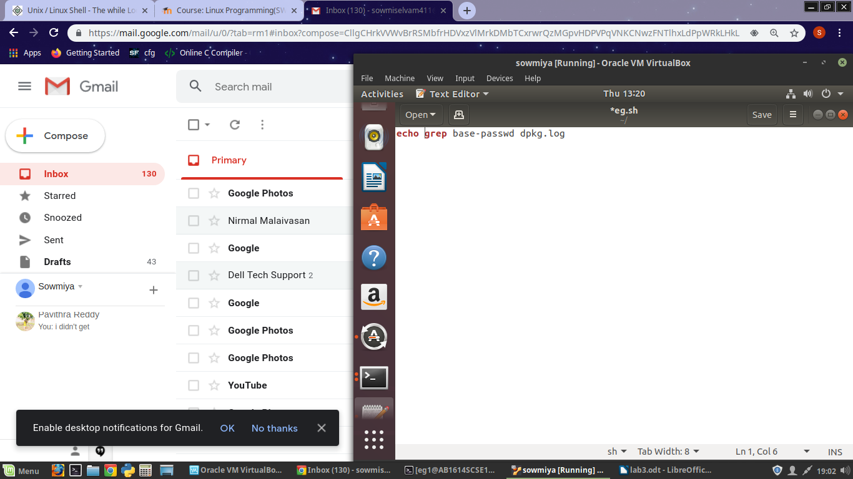

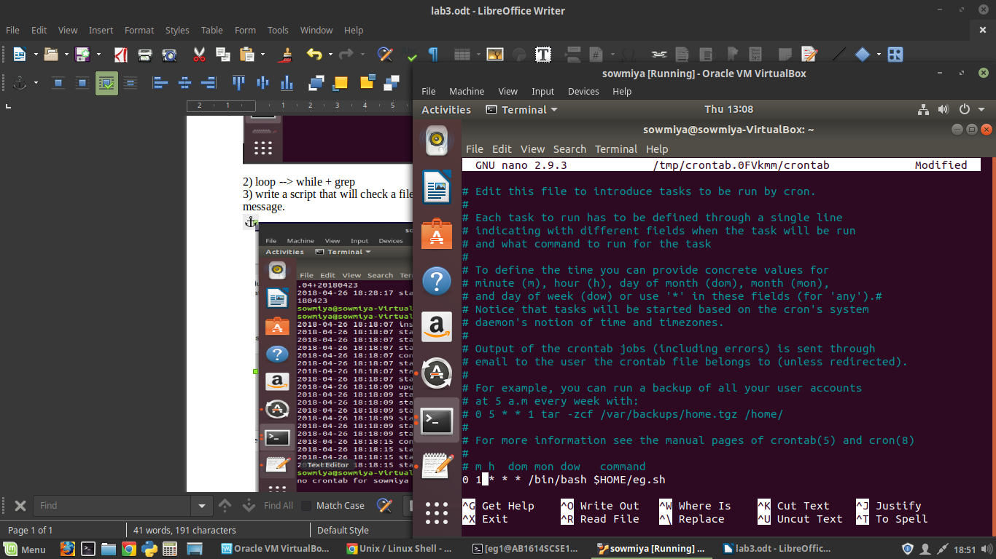

1. **Write a shell script to perform the following:**

**-> Measure the performance of a background process(p1)**

**->Display every 5 mins the cpu utilization**

